Informatics Institute

The AUM Informatics Institute offers the [Master in Cybersystems & Information Security](http://www.areslimited.com/csis/Master%20of%20Science%20in%20Cybersystems.docx) and is one of the first such programs to be offered in Alabama and has been the recipient of a $70,000 donation of equipment that allows a boost in research capabilities. The Institute is also responsible for bringing the [Twelfth Society for Design and Process Science Transdisciplinary Conference](http://areslimited.com/csis/sdps-transdisciplinary-conference) to Auburn Montgomery.

For more information about the Informatics Institute contact:   
**Dr. Mehmet Sahinoglu**  
Director of Informatics, Informatics Institute   
**334-244-3769**   
[msahinog@aum.edu](mailto:mashing@aum.edu)

**Graduate Assistantships Available** **for New and Current Graduate Students in Cybersystems and Information Security!**

Application Deadline EXTENDED:  **July 31, 2013**  
  
Click [**here**](http://areslimited.com/csis/csis-school-of-science-scholarship-application-2013-revised.pdf?sfvrsn=4) for complete details!

**AUM Cybersystems and Information Security Graduate Program Earns National Certification**

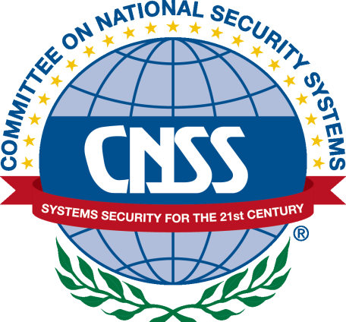  
  
  
[Click here for the official memo regarding the certification from the National Security Agency.](http://areslimited.com/csis/auburn-university-at-montgomery.pdf?sfvrsn=0)

*April 16, 2013*  
  
AUM recently applied to the National Information Assurance Education and Training Program (NIETP) of the National Security Agency for certification that the Cybersystems and Information Security degree meets the organization's stringent standards.   
  
The application was a success. Information Assurance Courseware Evaluation (IACE) Program evaluatorscertified AUM's course-ware as meeting all of the elements of the Committee on National Security Systems (CNSS) National Training Standard for information systems security professionals.  
  
In June 2013, AUM will receive recognition and an official certificate. The IACE Program provides consistency in training and education for the information assurance skills that are critical to our nation's security.  
  
AUM's CSIS graduate program reached this milestone after only two full academic years. In 2010, the program was first accredited and, in 2011, its first students enrolled.

**Degree Program**

The Informatics Institute offers the [M.S. in Cybersystems and Information Security](http://www.areslimited.com/csis/Master%20of%20Science%20in%20Cybersystems.docx). Click the link to learn more about the program.

For information on graduate admissions, click [here.](http://www.aum.edu/admissions/graduate-student-admission)

  
[Cybersystems & Information Security Degree Brochure](http://areslimited.com/csis/csisposter.pdf?sfvrsn=0)

Auburn University at Montgomery is Alabama's first program to offer a master's in cybersystems and information security to train future leaders in the field of information and network security. [**more**](http://blog.al.com/montgomery/2011/03/aum_to_offer_alabamas_first_in.html)

**Internet Security Radio Clips**

Listen to the Director of the Informatics Institute, Dr. Mehmet Sahinoglu, speak about Internet Security on the Community Focus program provided by Troy Public Radio.

[May 16, 2011](http://areslimited.com/csis/05-16-11_cf.mp3)  
[August 2, 2011](http://areslimited.com/csis/08-02-11_cf.mp3)

**Opelika-Auburn News Article**

[NSA certifies AUM's information security program.](http://areslimited.com/csis/20130717162011246.pdf?sfvrsn=0)

**WSFA 12 Talk Appearance**

WSFA talks with Program Director Dr. Sahinoglu and instructor Joel Junker about the Master of Science in Cybersystems and Information Security

**Informatics Gets Donation**

Integrated Computer Solutions, a Montgomery-based information security and technology consulting firm, recently donated approximately $70,000 in cutting-edge computer equipment to the Informatics Institute to help further the institute’s research mission.

**Montgomery Advertiser Article**

[AUM Growing With Cyber Security Part 1](http://areslimited.com/csis/mgmdc5-1_original.pdf?sfvrsn=0)  
[AUM Growing With Cyber Security Part 2](http://areslimited.com/csis/mgmdc5-2_original.pdf?sfvrsn=0)

**Dr. Sahinoglu talks about CSIS at the Eisenhower Lecture Series**

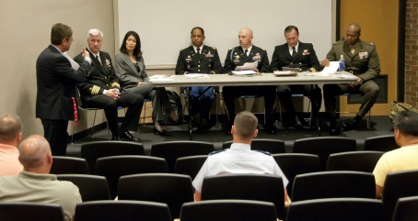  
*Informatics class at a panel discussion at the Eisenhower National Security Lecture Series at AUM*